Michael Starace

IT114-005

**Java Loops HW**

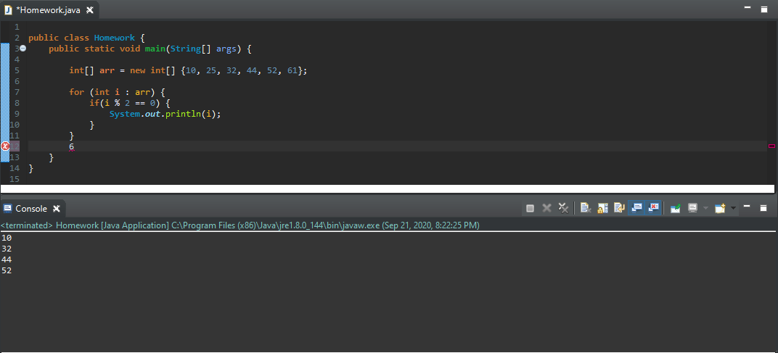

First, I created and populated an array.

Then, I used a for loop to go through each number in the array and print its value.

Finally, I used an if loop to print only the numbers that are divisible by 2 (even numbers).